Snowflake and Einstein Analytics

|  |  |
| --- | --- |
| **Summary** | Setting up an account, connected Snowflake with Einstein Analytics, Creating dashboard on a dataset and checking SAQL Queries |
| **URL** | <https://s3.amazonaws.com/snowflake-workshop-lab/Snowflake_free_trial_LabGuide.pdf>  <https://docs.snowflake.com/en/user-guide/data-load-internal-tutorial-create-file-format.html>  <https://docs.snowflake.com/en/user-guide/sample-data-tpcds.html>  <https://salesforce-trailblazer.com/snowflake-einstein-analytics/>  <https://www.salesforceblogger.com/all-about-saql/> |
| **Tools** | SnowFlake and Einstein Analytics(Tableau CRM) |

Snowflake Guidbook and Data Loading Tutorials

TPC DS

SnowFlake and Einstein Analytics

SAQL Guidlines

# **Snowflake Guidebook and Data Loading Tutorials**

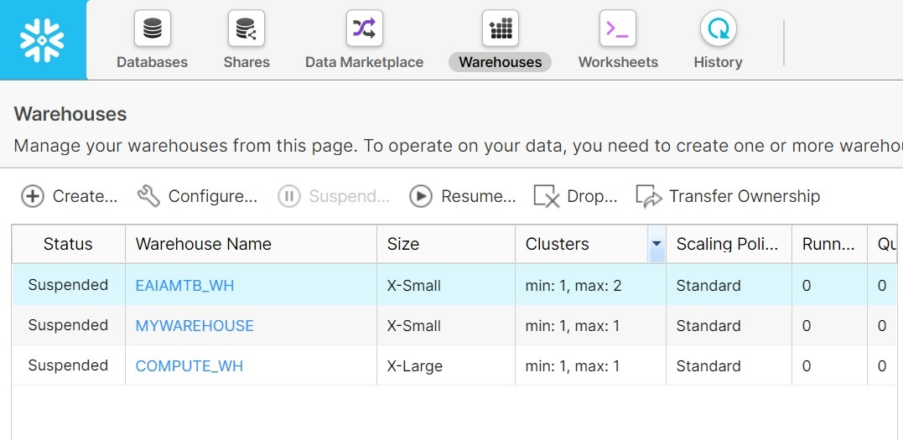

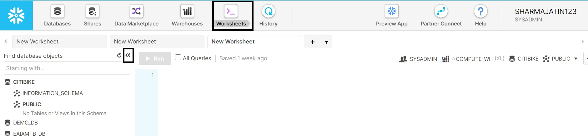

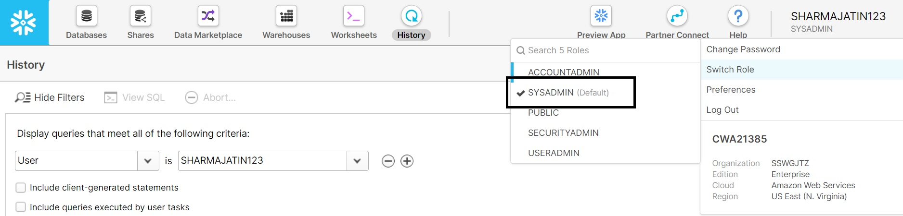

# **TPC DS**

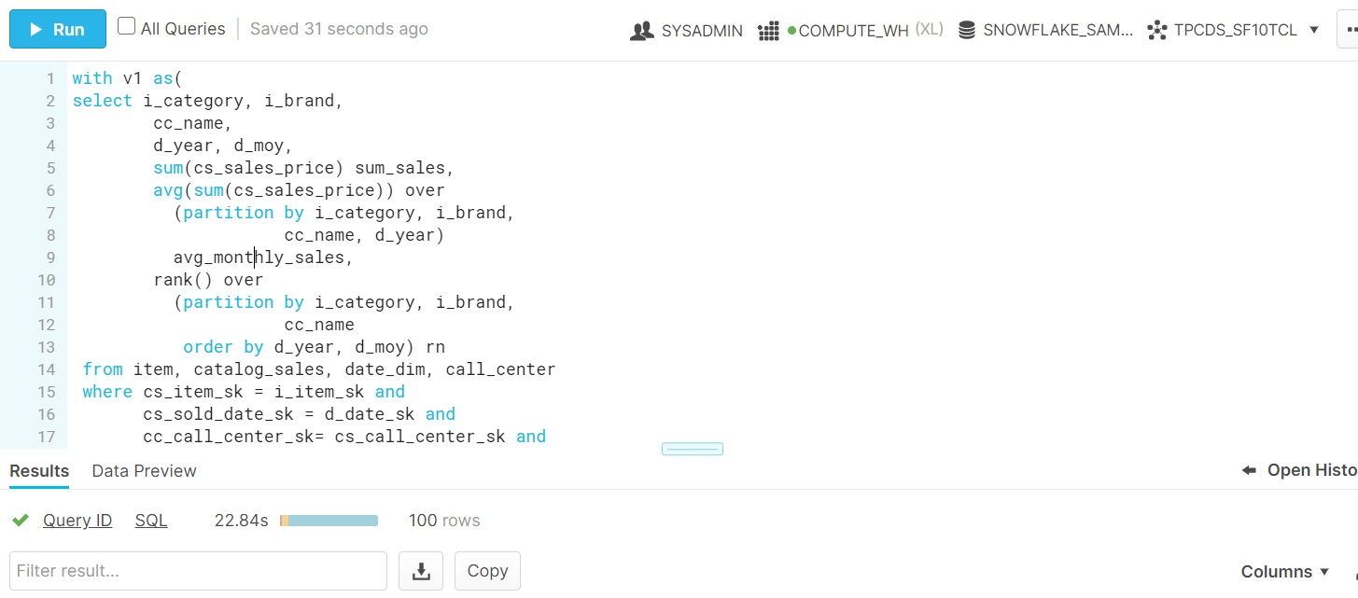

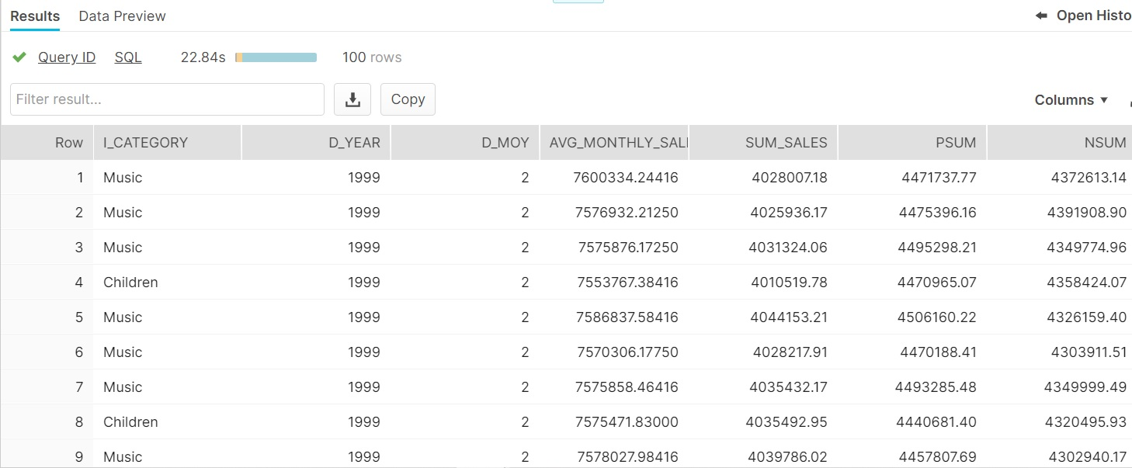

# **Snowflake and Einstein Analytics**

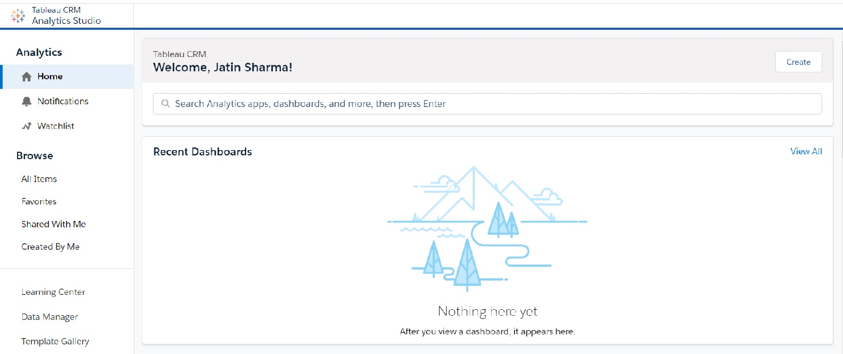

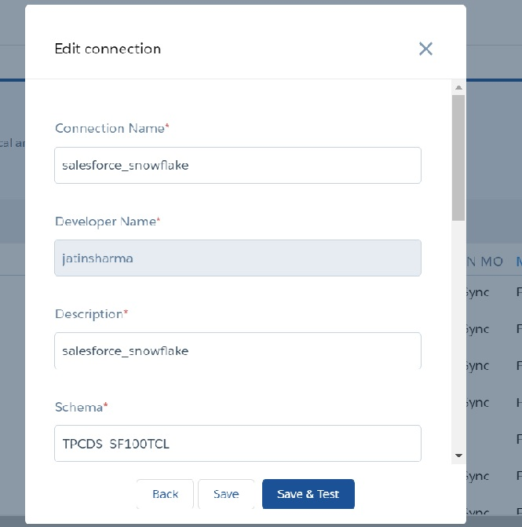

# **SAQL**

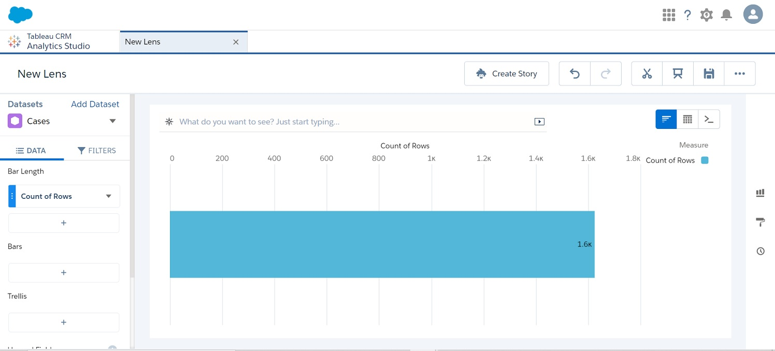

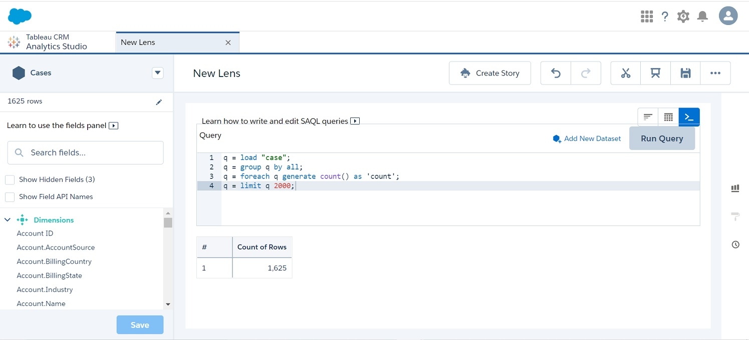

# **3 Lesson Learned**

1. SAQL Queries are easy to understand and generate interactive dashboard.
2. Snowflake allows convenient collaboration between the teams.
3. Can create multiple data warehouses, worksheets and databases as per the project requirement.